NetTower User Guide

Application: NetTower
Purpose: End-user guide for launching sessions, using topology views, controlling discovery settings, and troubleshooting.
Version Scope: Current Electron frontend and Python backend runtime behavior.

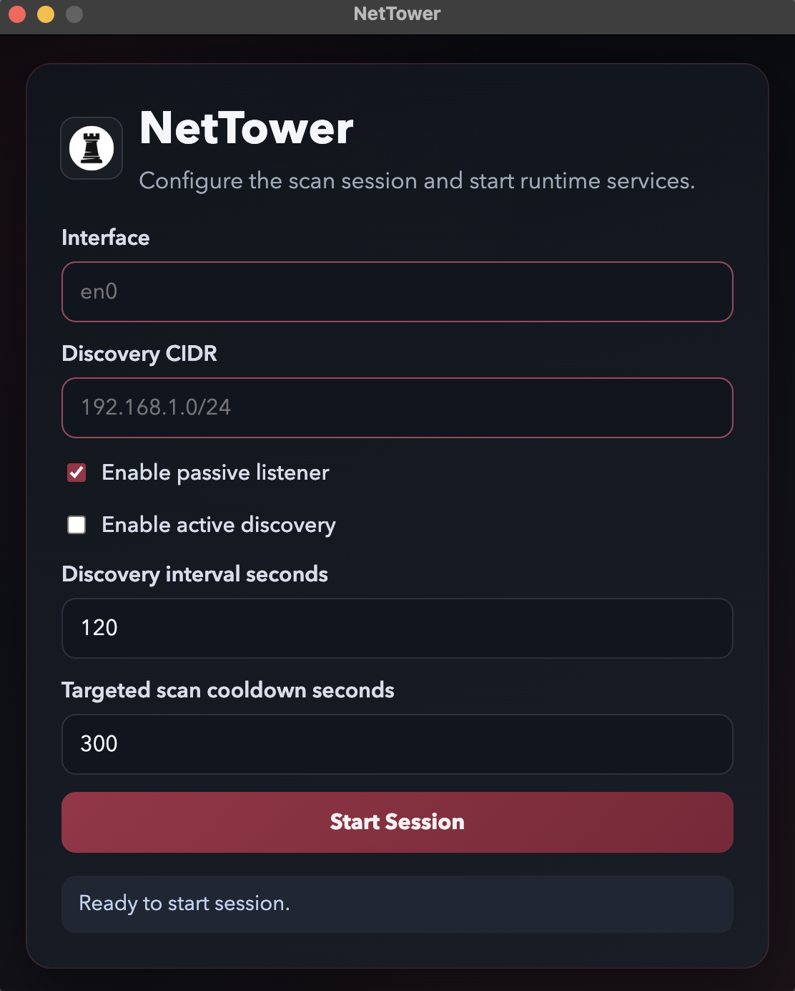
=====================================================================
1) WHAT NETTOWER DOES
=====================================================================
NetTower is an agentless network discovery and topology application.
It observes and infers devices and communication behavior, then renders live topology.

Core capabilities:
- Network topology visualization (2D + optional 3D + Idle wallboard mode)
- Node-centric exploration (click nodes for details)
- Host classification and role inference
- Connectivity relationship rendering (edges)
- Activity heat mapping by recency
- Dynamic updates as network state changes
- Interactive navigation (pan/zoom/camera)
- User-controlled scanning and discovery settings

=====================================================================
2) SESSION LIFECYCLE
=====================================================================
Startup flow:
1. Open NetTower.
2. Fill all required launch fields.
3. Press Start Session.
4. NetTower starts backend runtime and waits for readiness.
5. Dashboard opens when backend is ready.
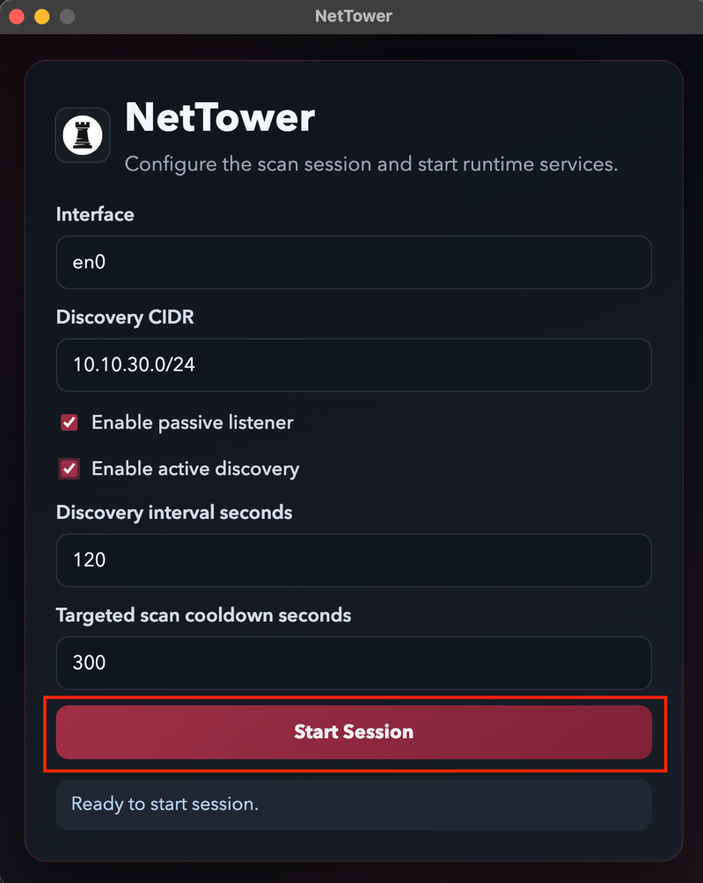

Shutdown flow:
1. Press Stop Session in the dashboard top bar.
2. NetTower requests clean backend shutdown.
3. Application returns to launch screen.

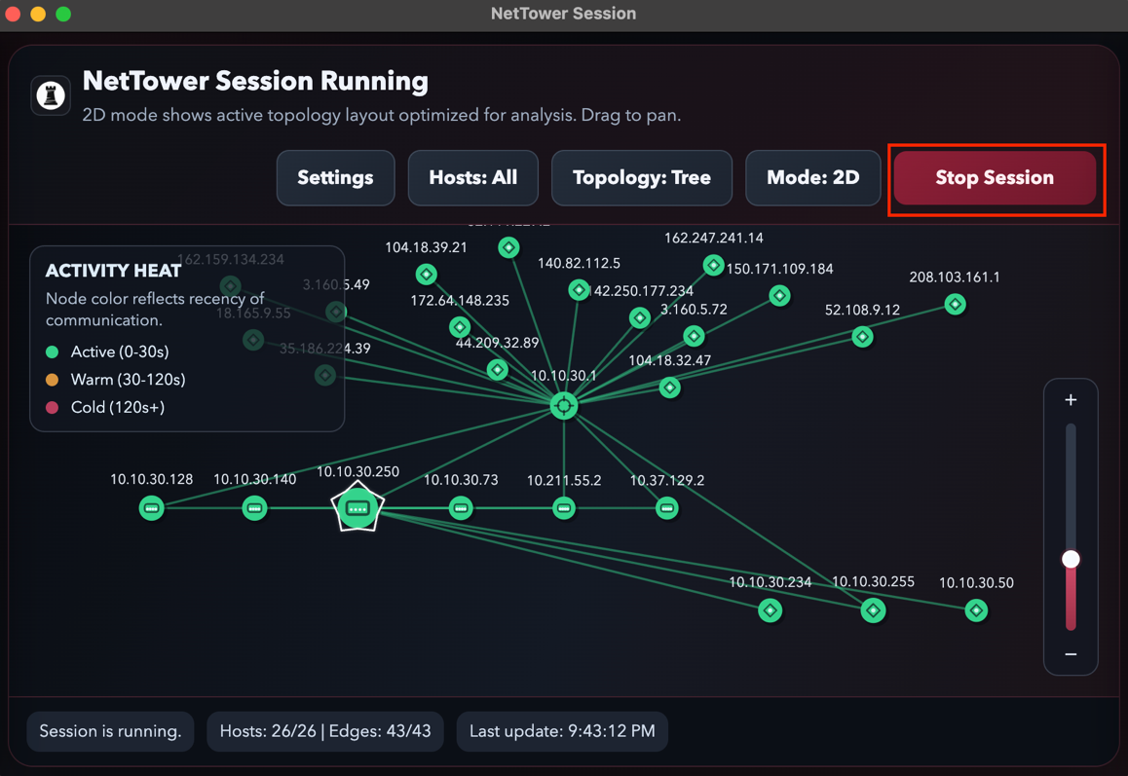

=====================================================================
3) LAUNCH CONFIGURATION SCREEN
=====================================================================
All fields are required.

Field: Interface
- Description: Network interface used for observation and discovery.
- Validation: Required, interface format only.

Field: Discovery CIDR
- Description: Target range for interval discovery (example: 10.10.30.0/24).
- Validation: Required, valid IPv4 CIDR.

Field: Enable Passive Listener
- Description: Enables passive data collection from observed traffic.
- Behavior: ON by default.

Field: Enable Active Discovery
- Description: Enables probe-based discovery.
- Behavior: OFF by default unless user enables it.

Field: Discovery Interval Seconds
- Description: How often interval discovery runs.
- Validation: Required integer >= 1.

Field: Targeted Scan Cooldown Seconds
- Description: Minimum delay between targeted scans of the same host.
- Validation: Required integer >= 0.

Important validation behavior:
- At least one discovery mode must be enabled.
- Invalid interface/CIDR/numeric values block Start Session.

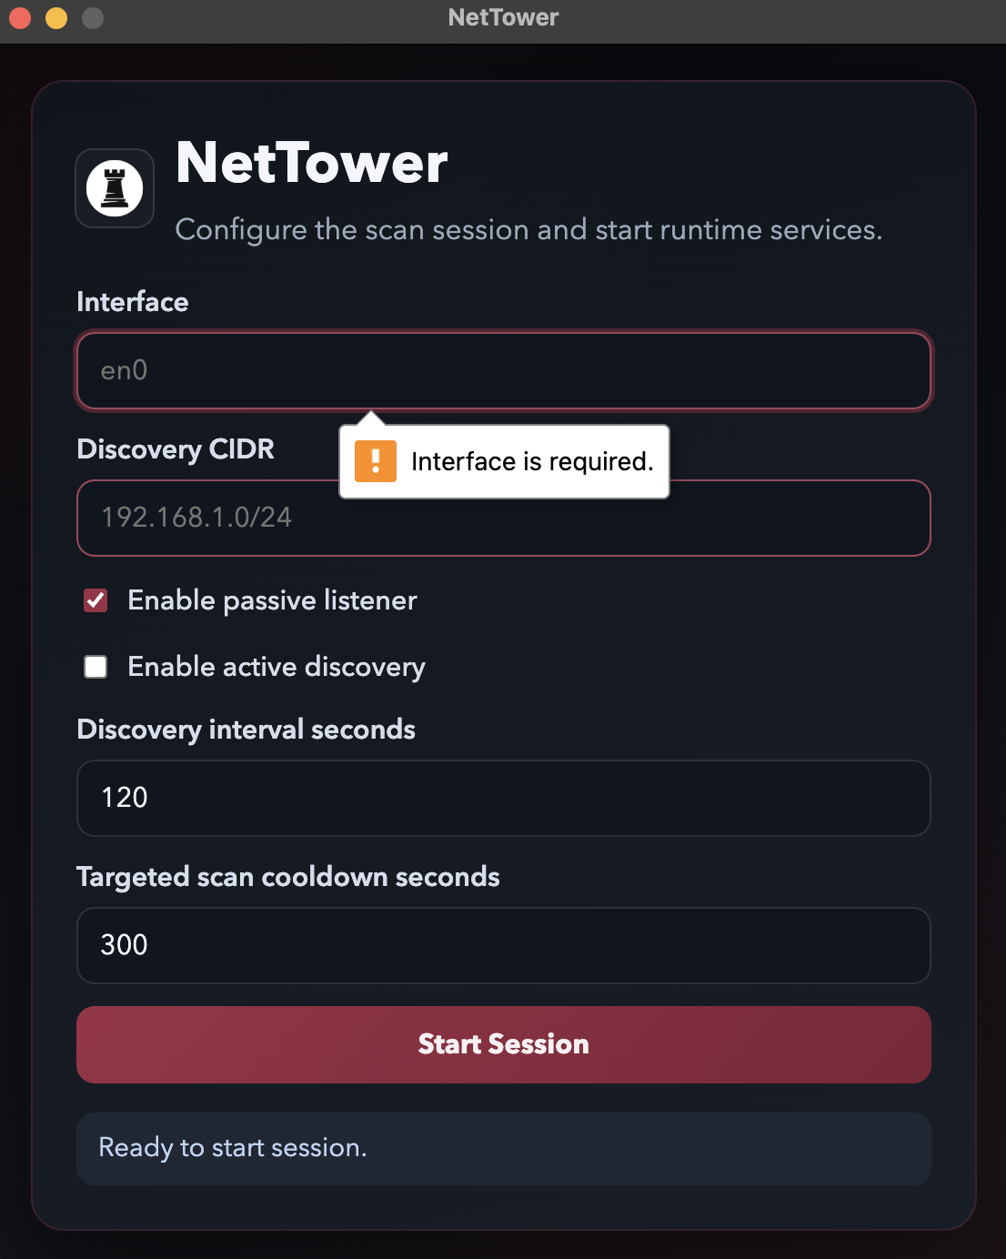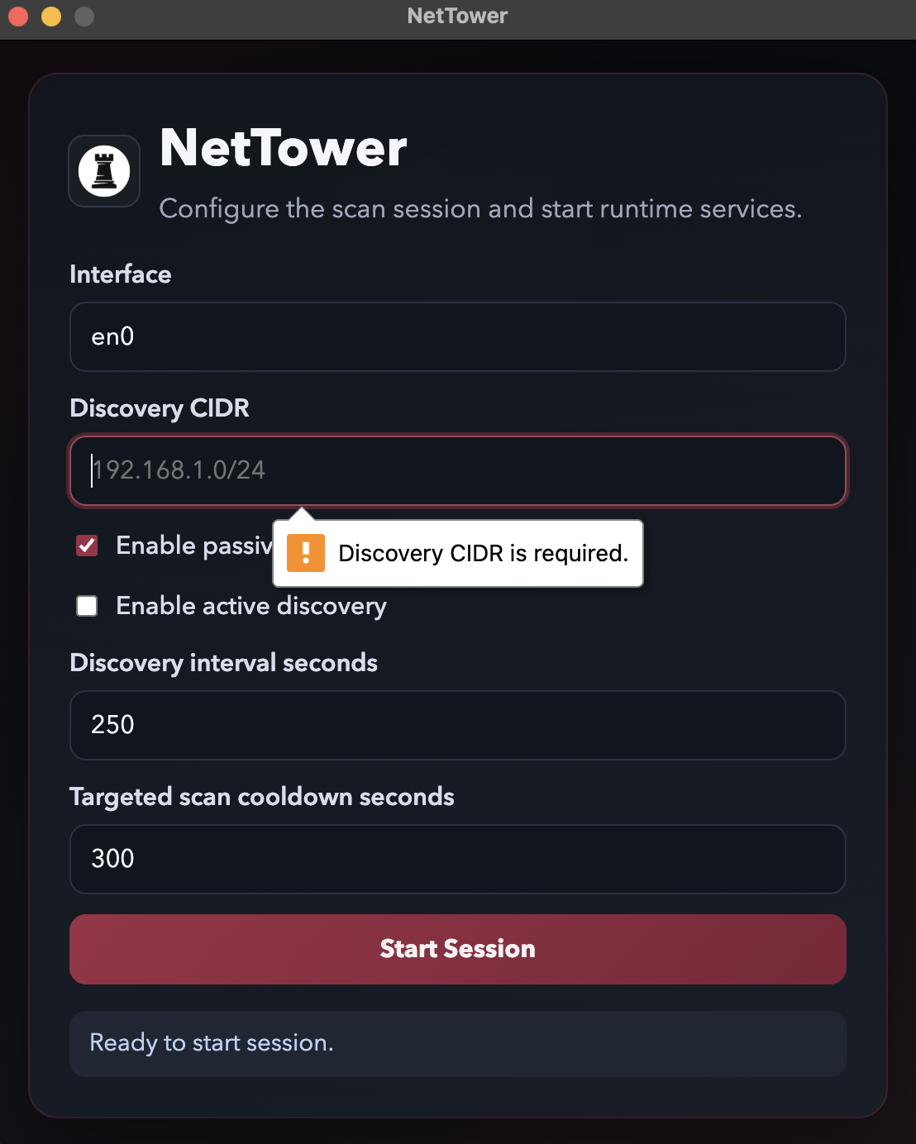
=====================================================================
4) MAIN DASHBOARD OVERVIEW
=====================================================================
Top bar controls:
- Settings
- Hosts: All / Public / Private
- Topology: Tree / Star
- Mode: 2D / 3D / Idle
- Stop Session


Activity heat legend:
- Active (0-30s): Green
- Warm (30-120s): Amber
- Cold (120s+): Red

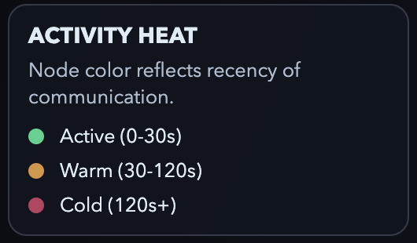
=====================================================================
5) TOPOLOGY VIEWS AND MODES
=====================================================================
Mode: 2D
- Primary analysis mode
- Supports panning and zooming
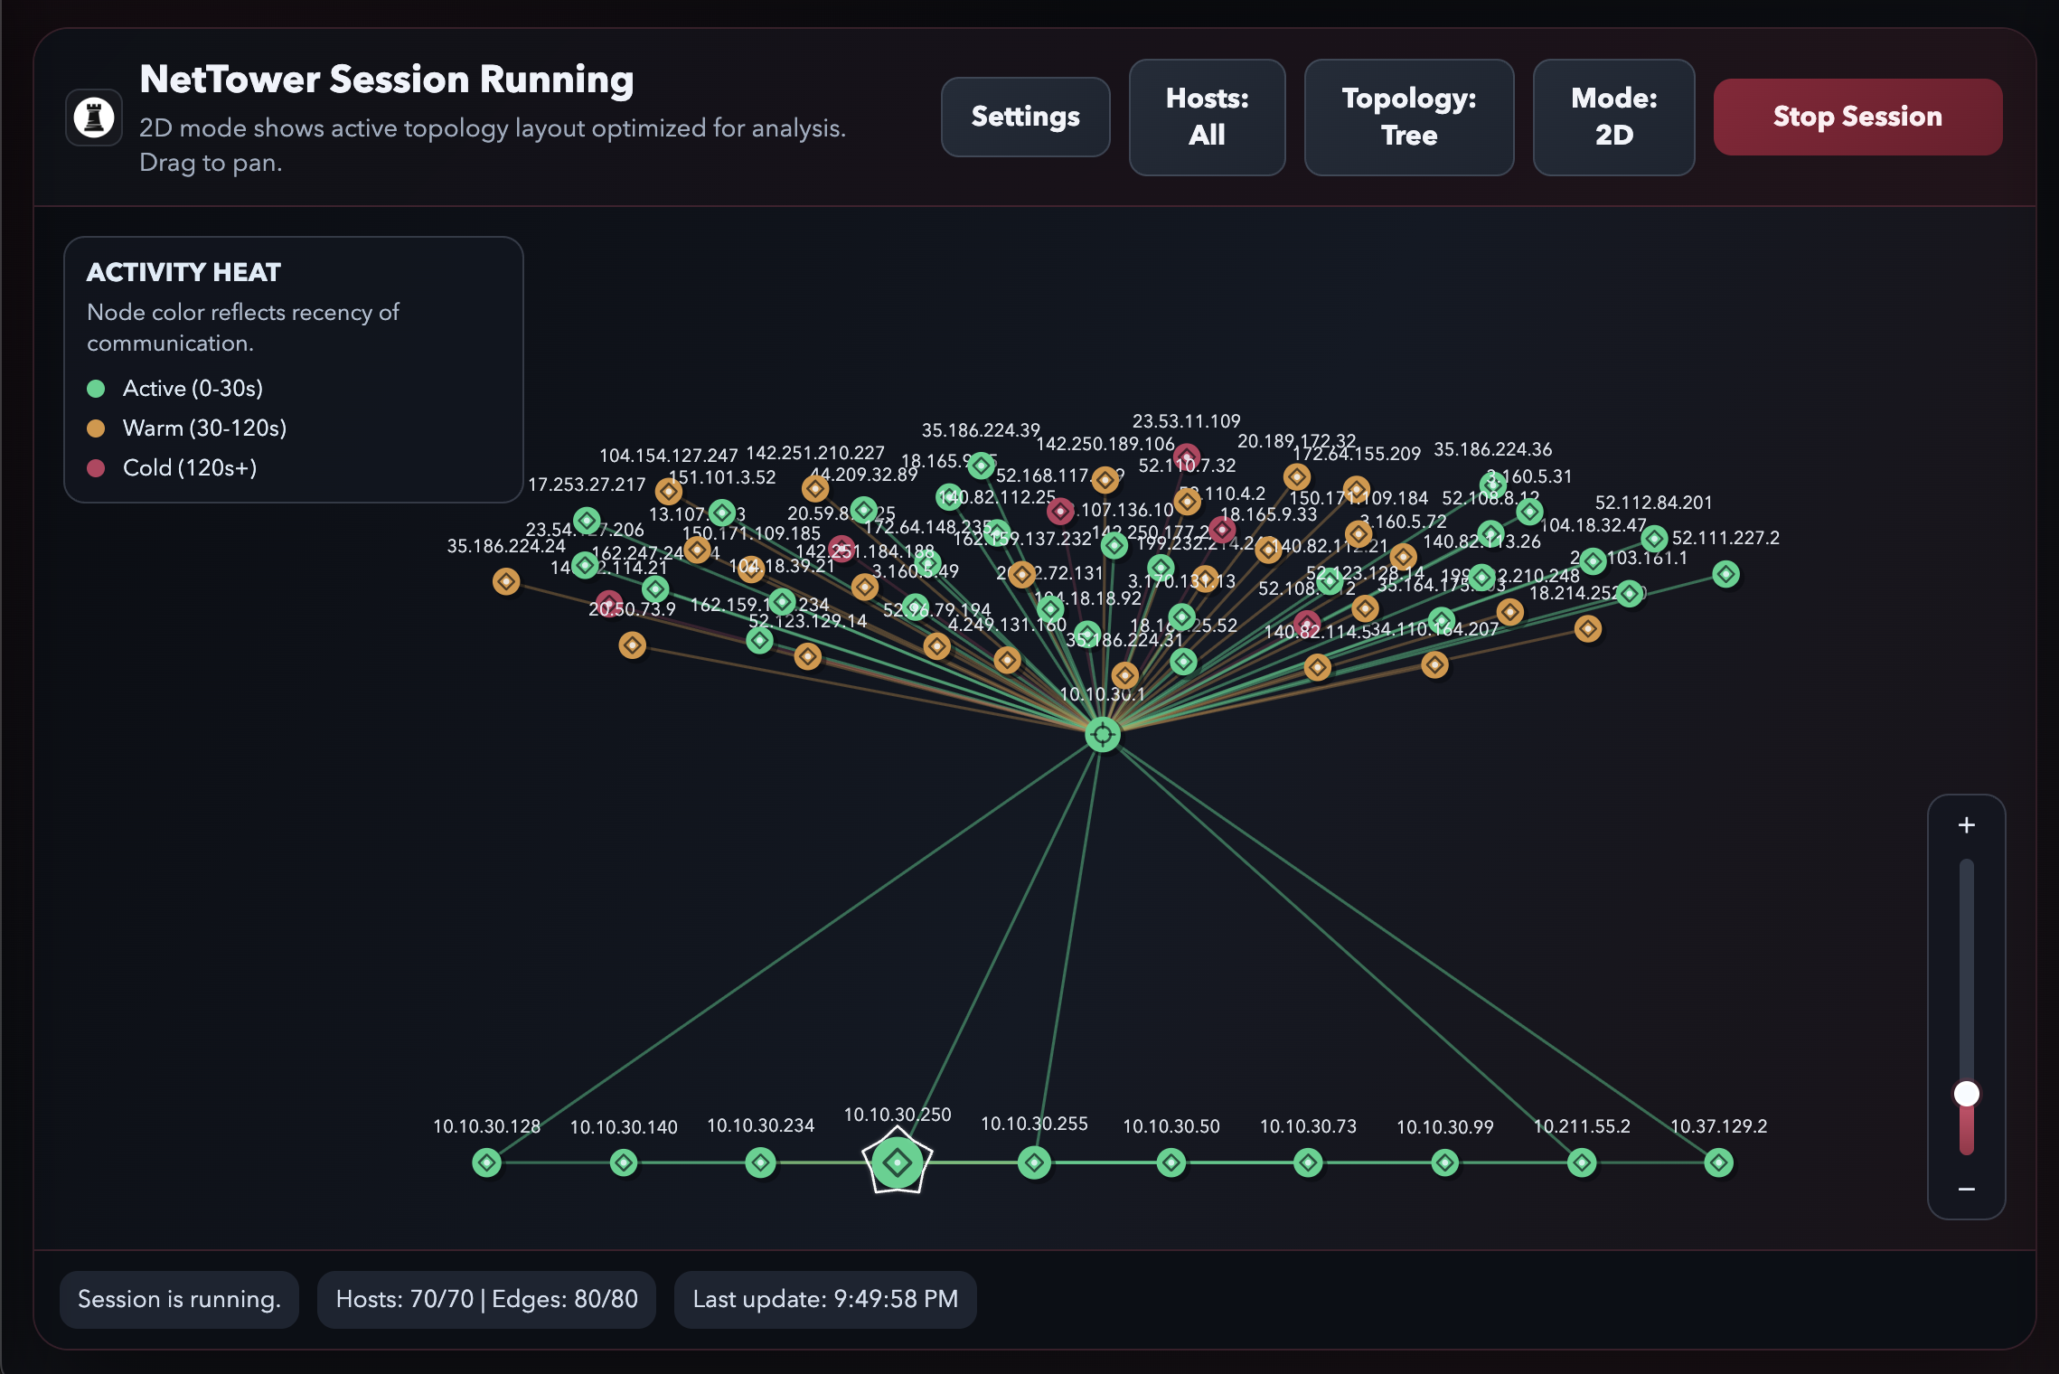
Mode: 3D
- Perspective view with interactive camera controls
- Supports orbit, pan, and zoom camera movement
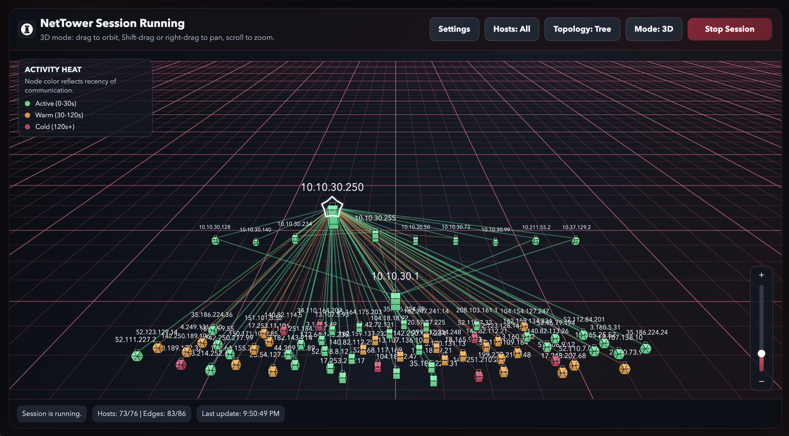
Mode: Idle
- Continuous rotating display suitable for monitor/wallboard view
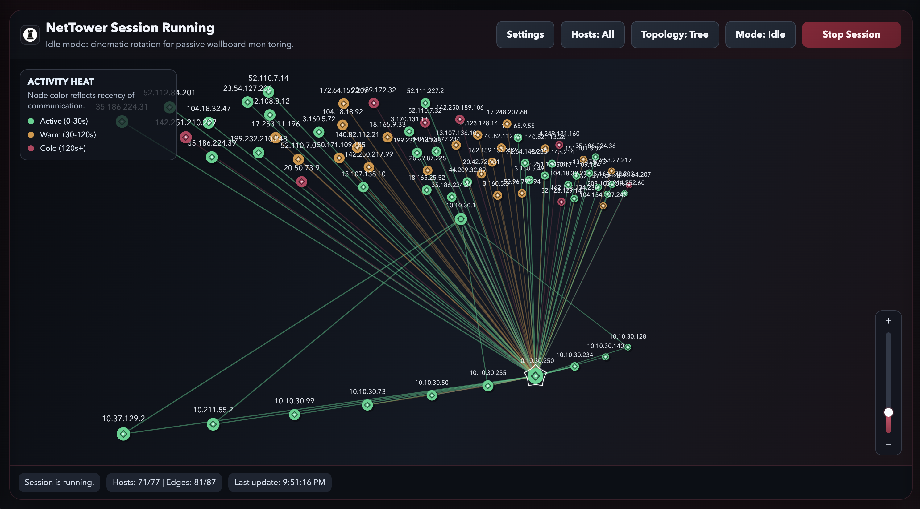

=====================================================================
6) TOPOLOGY LAYOUT OPTIONS
=====================================================================
Layout: Tree (default)
- Top-down hierarchy of inferred network structure
- Intended to separate upstream/public, gateway/router, and internal hosts
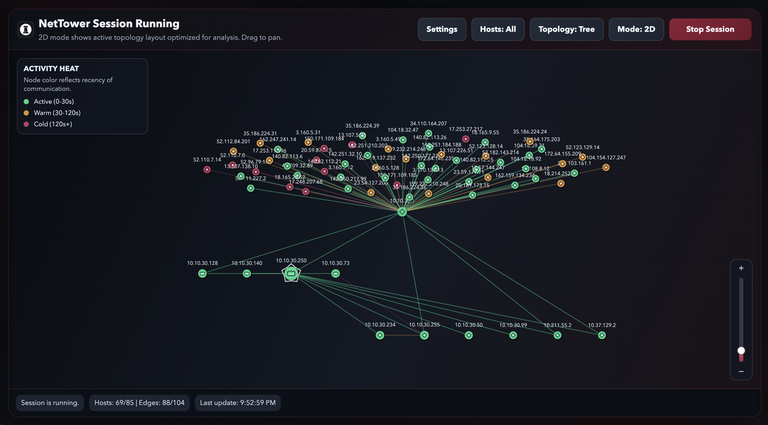

Layout: Star
- Relationship-centric layout around key hosts
- Good for quickly seeing direct communication patterns

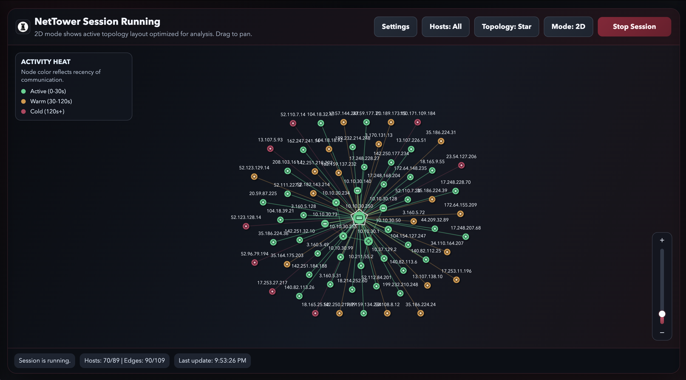

=====================================================================
7) NODE-CENTRIC EXPLORATION
=====================================================================
Each host is a selectable node.
Clicking a node opens a right-side host details panel.

Host details include:
- Host ID
- IP addresses
- MAC addresses
- Hostnames
- Vendor
- OS guess
- Detailed role + confidence
- Topology role + confidence
- Parent candidate + confidence
- Topology layer
- First seen / Last seen
- Ports and services (when available)

Special marker:
- The machine running NetTower is visually marked for identification.

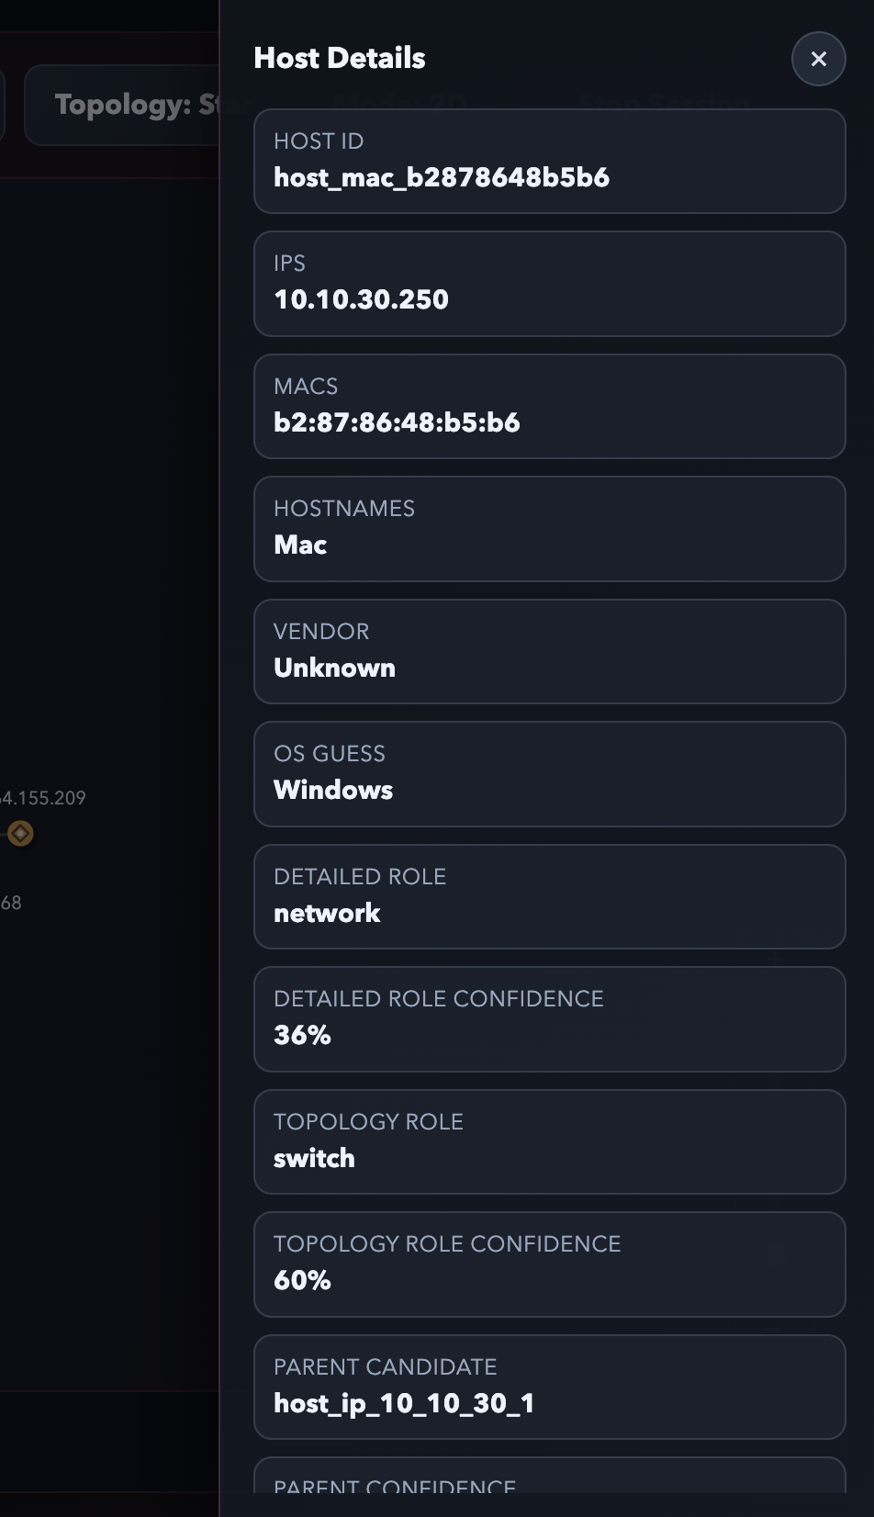
=====================================================================
8) CONNECTIVITY REPRESENTATION
=====================================================================
Observed or inferred relationships are rendered as edges.
Edge data updates as new traffic/discovery events are processed.
Tree mode uses inferred relationship metadata to improve hierarchy readability.

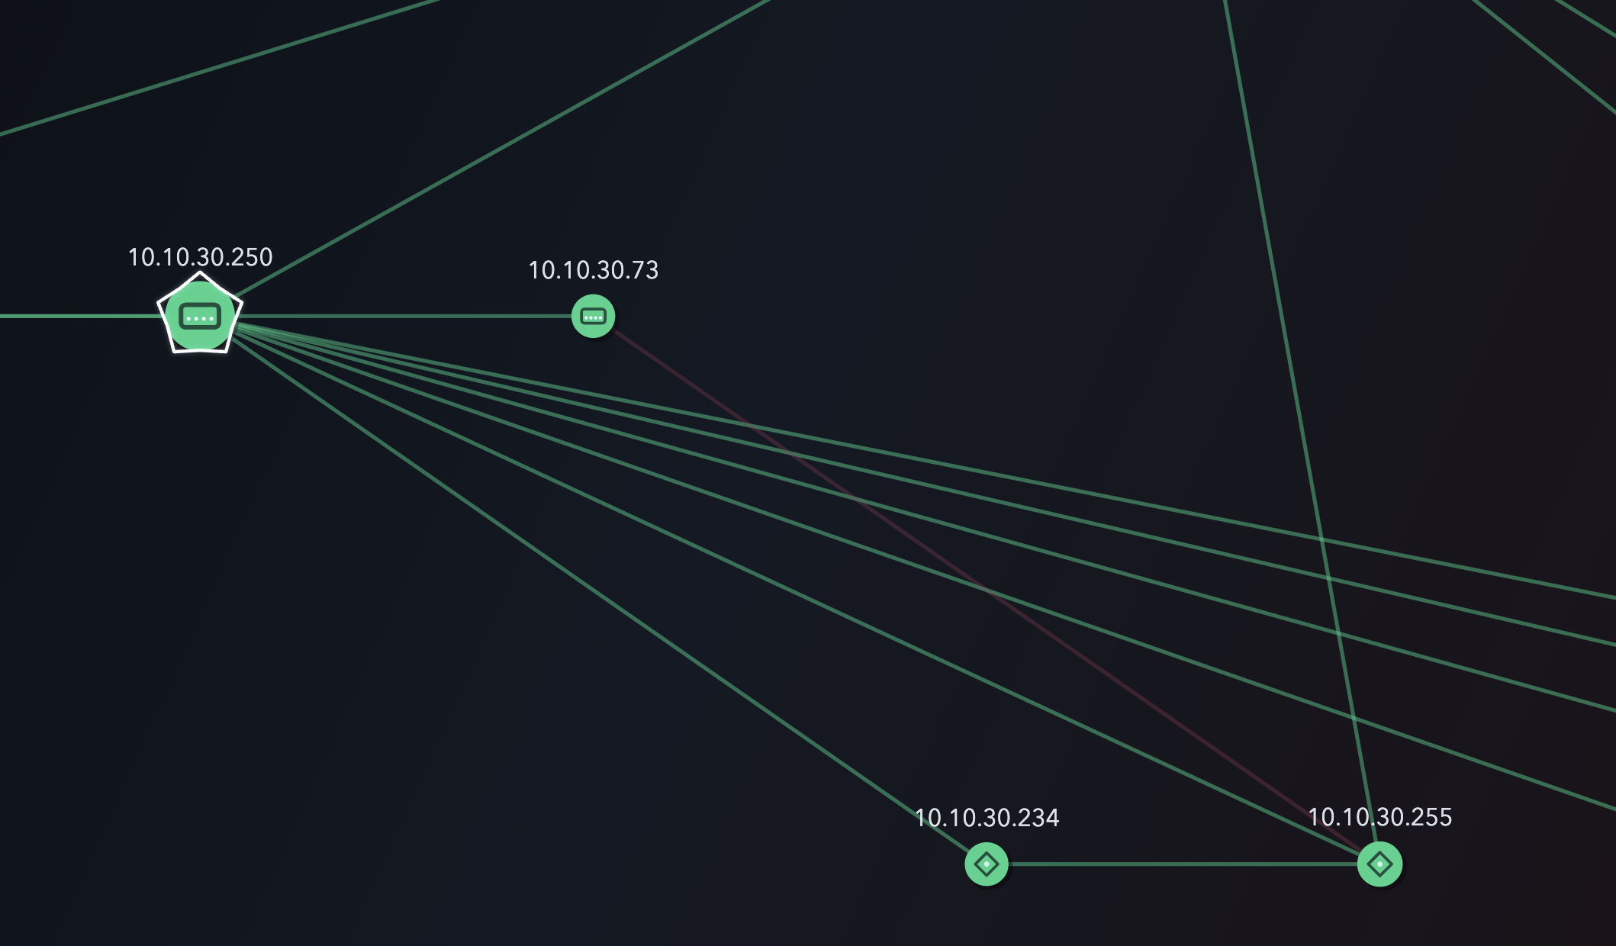
=====================================================================
9) HOST IDENTIFICATION AND CLASSIFICATION
=====================================================================
NetTower differentiates hosts using inferred role categories:
- Router/Gateway
- Switch/Network Device
- Server
- Workstation/Client
- Other/Unknown

Important:
- Role inference is probabilistic, not guaranteed ground truth.
- Confidence values are shown in host details to indicate certainty.

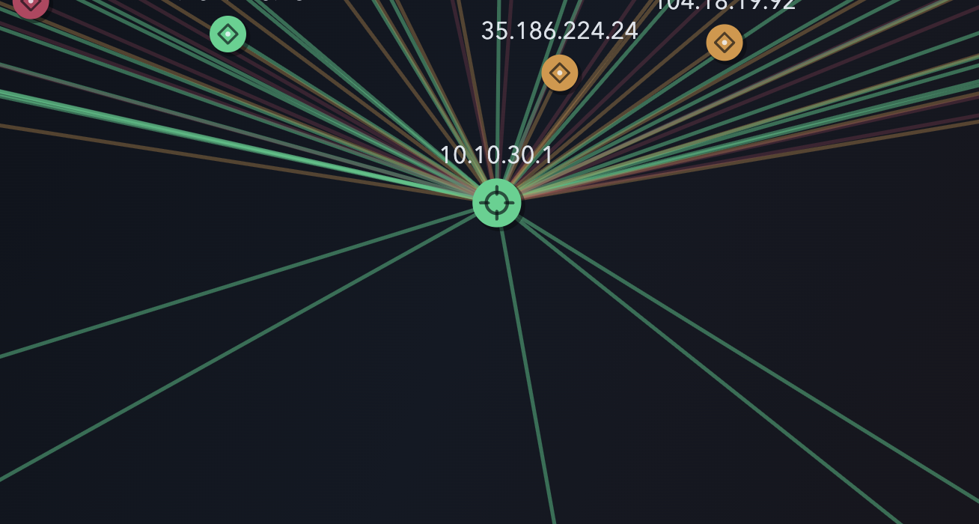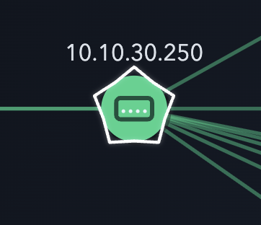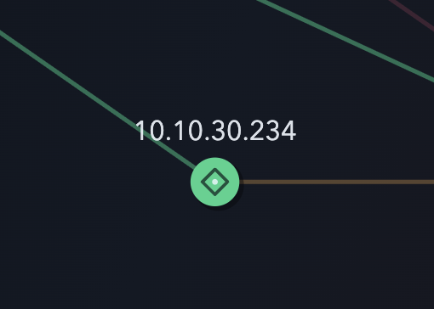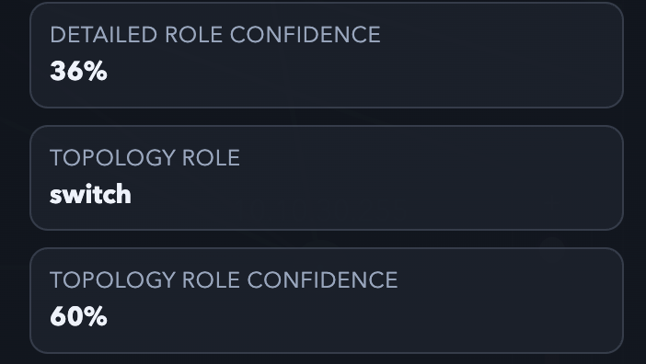

=====================================================================
10) INTERACTIVE NAVIGATION CONTROLS
=====================================================================
2D controls:
- Drag to pan view
- Vertical zoom slider at bottom-right
- Plus at top / Minus at bottom
- Red fill indicates zoom level on slider

3D controls:
- Drag: orbit camera
- Shift-drag or right-drag: pan camera
- Mouse wheel: zoom camera

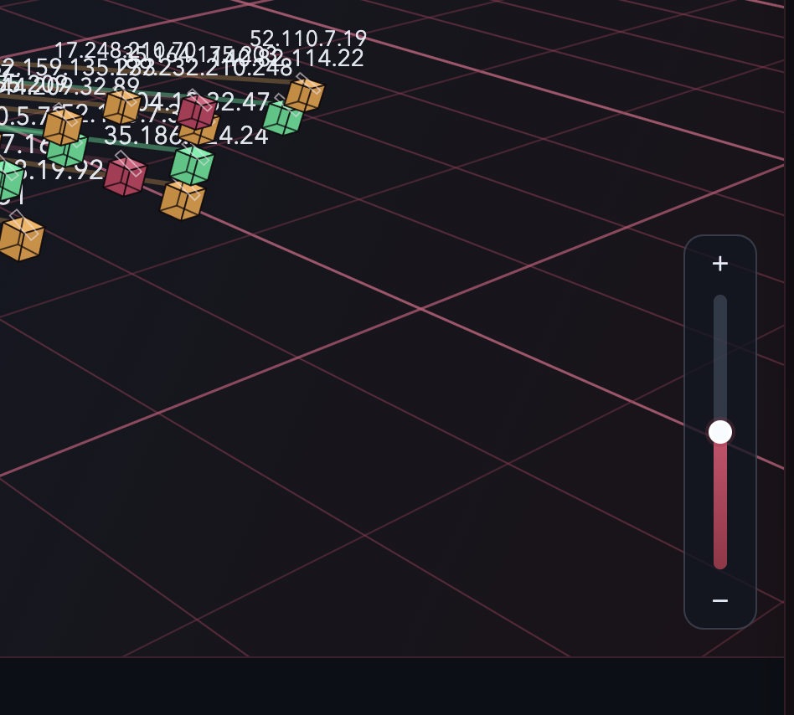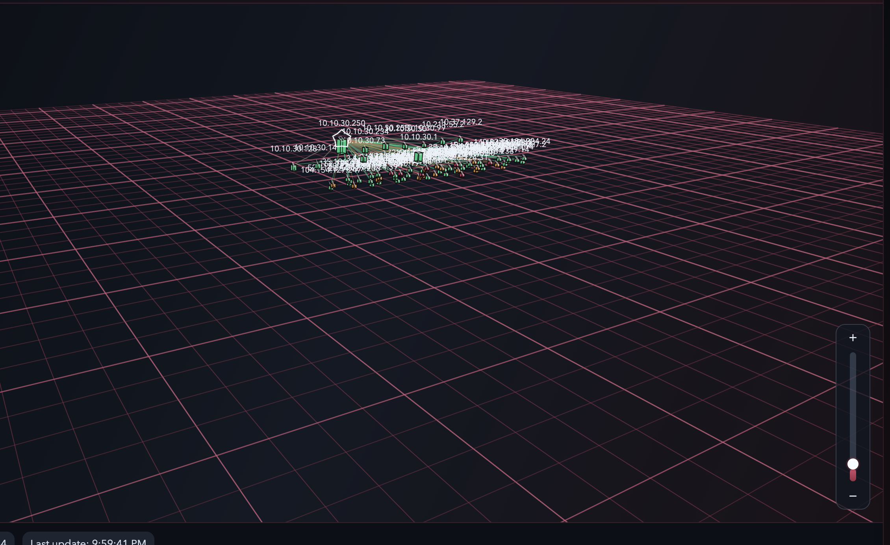

=====================================================================
11) SETTINGS PANEL
=====================================================================
Settings includes at least:
- Display tab
- Data tab

11.1 Display Settings
- Hide stale hosts (default ON)
- Hide host after N seconds (editable when stale hiding is ON)
- Keep stale private hosts (dependent on stale host setting)
- Refresh interval
- Host render limit
- Edge render limit

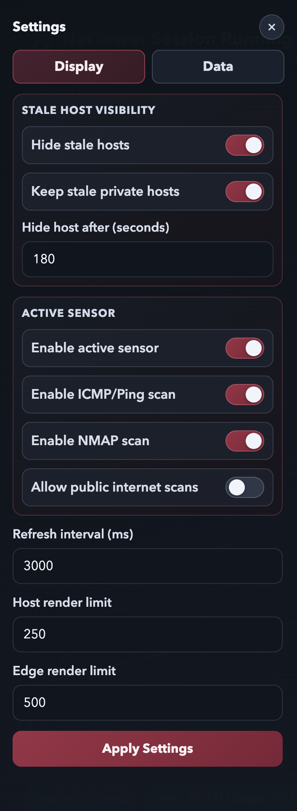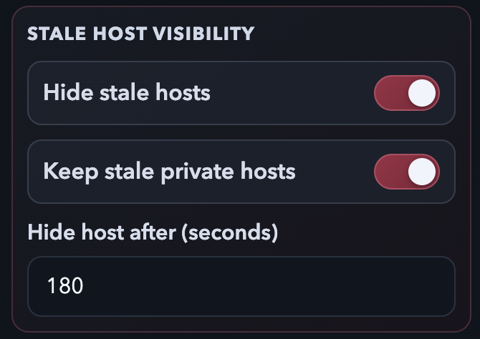
11.2 Active Discovery Settings
- Enable active sensor
- Enable ICMP/Ping scan (only interactable when active sensor ON)
- Enable NMAP scan (only interactable when active sensor ON)
- Allow public internet scans (confirmation prompt required)

Safety behavior:
- Public active scanning is restricted by default.
- Enable only with proper authorization.
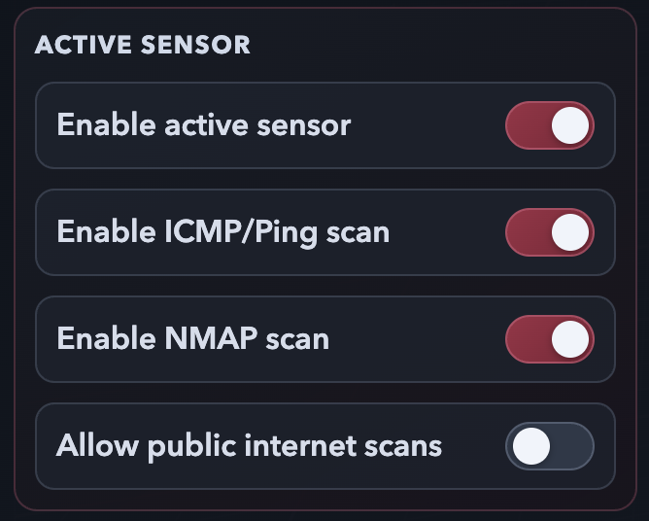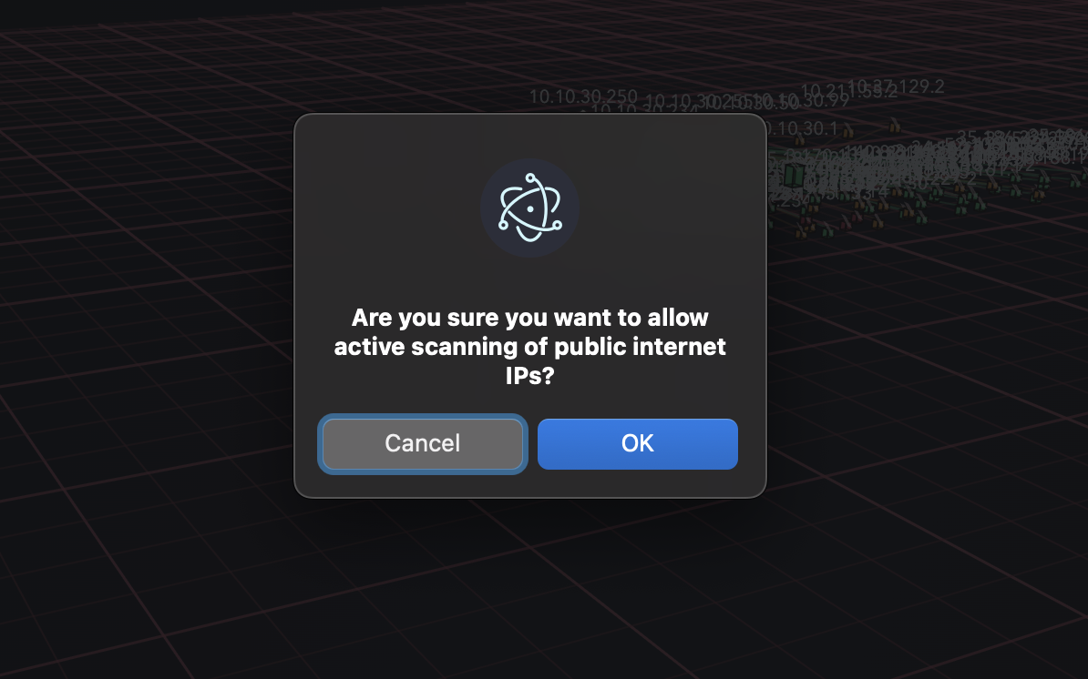

11.3 Data Tab
- Clean text listing of current hosts and edges
- Refresh control for latest data snapshot

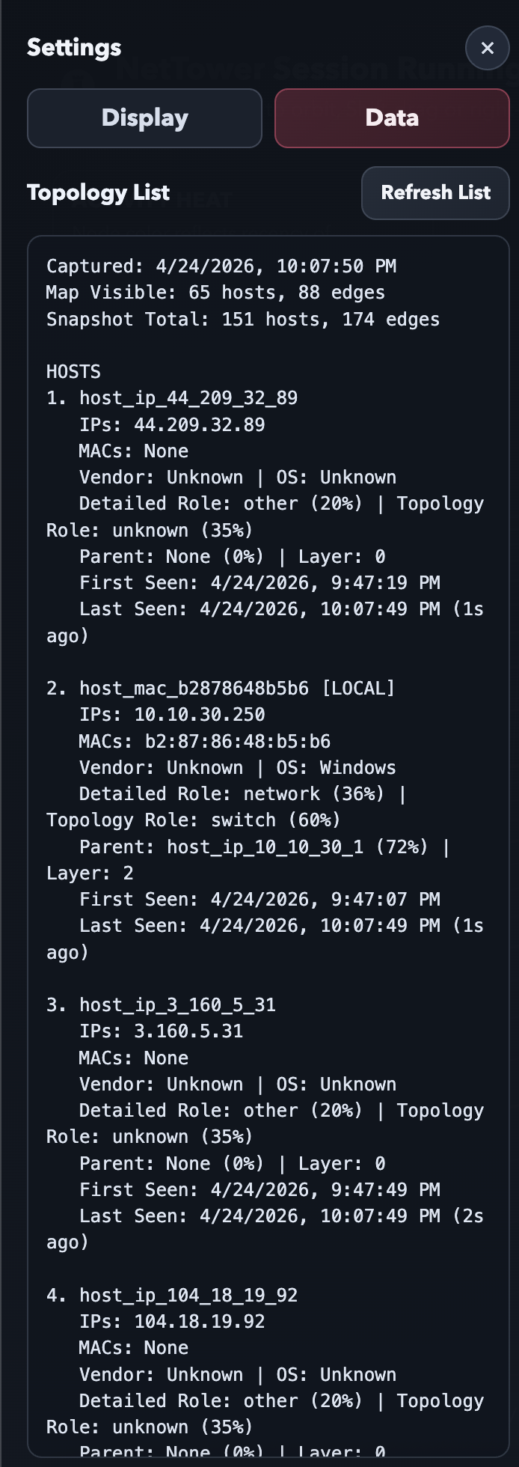
=====================================================================
12) SCANNING MODEL (USER LEVEL)
=====================================================================
Passive discovery:
- Agentless observation from network traffic
- Useful for discovering active relationships naturally seen on the network

Active discovery:
- Probe-based scanning when enabled
- Can use ICMP, NMAP, or both (depending on toggles)
- Scope controlled by launch and settings configuration

Combined operation:
- Passive and active can run together
- Passive preserves traffic-observation context
- Active adds additional host/service signals when enabled

=====================================================================
13) DYNAMIC UPDATES AND HEAT MAPPING
=====================================================================
NetTower continuously refreshes topology state:
- New hosts appear as they are observed or confirmed
- Inactive hosts age and can be hidden based on stale settings
- Node color updates according to communication recency
- Edges update as relationships are observed/inferred
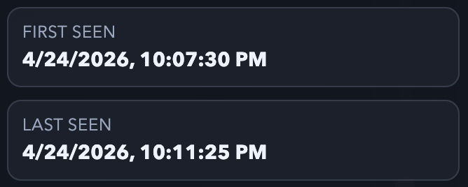
=====================================================================
14) TROUBLESHOOTING
=====================================================================
Issue: Failed to start session / Python bridge exited
- Verify Python environment and backend dependencies.
- Check backend/runtime logs for startup exceptions.

Issue: Stuck waiting for backend readiness
- Backend may not have created readiness flag yet.
- Check runtime and backend logs.

Issue: "nmap not found"
- Nmap is not installed or not in the PATH used by backend runtime.
- Install Nmap and confirm the executable is discoverable before launching app.

Issue: No edges or very few hosts shown
- Verify passive listener is enabled.
- Check render limits and host filters.
- Confirm active settings are not overly restrictive.

Issue: Hosts unexpectedly disappear
- Check stale host hiding threshold and stale-private toggle behavior.

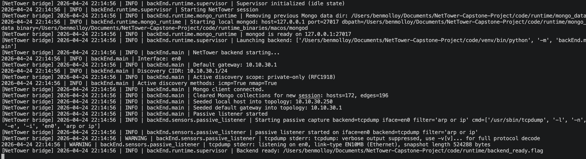
=====================================================================
15) QUICK WORKFLOWS
=====================================================================
Workflow A: Monitor local network safely
1. Enable passive listener.
2. Keep active discovery OFF initially.
3. Start session and inspect tree view.
4. Use host filter and details drawer to validate known devices.

Workflow B: Add active context safely
1. Enable active sensor in settings.
2. Keep public scanning OFF.
3. Use ICMP and NMAP toggles based on need.
4. Observe new enrichment in host details.

Workflow C: Export-readable view for review
1. Open Settings -> Data tab.
2. Refresh host/edge list.
3. Capture text output and screenshots for reports.

=====================================================================
16) TERMS
=====================================================================
Host:
- Discovered network entity represented as a node.
Edge:
- Observed or inferred relationship between hosts.
Passive Discovery:
- Traffic observation without direct probes.
Active Discovery:
- Direct probing (ICMP and/or NMAP depending on settings).
Stale Host:
- Host not observed within configured age threshold.
Role Confidence:
- Confidence value for inferred role labels.

